
THE TEENAGERS№1

Взгляд в будущее  In the future , robots will change people. Robots will be doctors, teachers.Students and pupils will go to the museums and theatres by the computers-virtual, as today. Nanorobots will be able to travel through our bodies better that scientists and doctors. Only one or two people will have a car, because computer can drive us from Moscow to London, while we are sleeping.  ( Batmanova S)  I think that our future will be interesting. Computer technologies will be cheaper. The Internet will be faster than now.In 50 years people will become better and cars will drive faster. ( Danilyk S.) | Фото номера  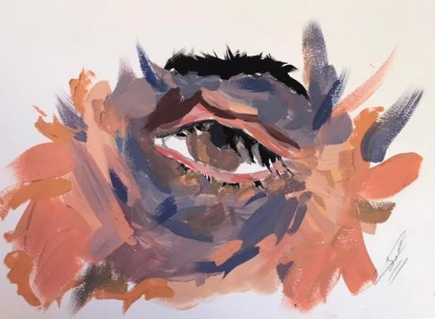  Картина Чиаева А.7 класс  «Всевидящее Око»
Путевые заметки
Moscow is the capital of Russia, its political, economic and cultural center. It was founded 8 centuries ago by Prince Yuri Dolgoruky. Historians have accepted the year of 1147 as the start of Moscow's history. In the 16th century under Ivan the Terrible Moscow became the capital of the new united state. Though Peter the Great moved the capital to St. Petersburg in 1712, Moscow remained the heart of Russia.Now Moscow is one of the largest cities in Europe. Its total area is about 900 square km. The population of the city is over 10 million people.Moscow is one of the most beautiful cities in the world. The heart of Moscow is Red Square. The Kremlin and St. Basil's Cathedral are masterpieces of ancient Russian architecture. The main Kremlin tower, the Spasskaya Tower, has become the symbol of the country. On the territory of Kremlin you can see old cathedrals, the Bell Tower, the Palace of Congress, the Tzar- Cannon and the Tzar-Bell, the biggest cannon and bell in the world. St. Basil's Cathedral was built in the mid-16th century in memory of the victory over Kazan.

С миру по нитке
Great Britain
Mother’s Day is celebrated three weeks before Easter. On this day mother is rewarded for all she does for her children and family in general. (Bestaeva V.)
Halloween is celebrated on 31 st October. Some people believe that on this evening the spirits of the dead return to where the used to live.( Dzanagova A.)

America ( August 29, 2005 )
Hurricane Katrina has hit New Orleans with winds of 200 kilometers per hour. Large areas of the city have been flooded and emergency services were looking for survivors. The leeves wich protect the city have broken and the waters of Lake Pontchartrain are pouring through the streets(Gabaraev D. Kasperovich L.)

Ждем Ваших заметок и интересных историй.
Говорим по английский  Боже мой! Вчера - ненастье... (1855) А.Майков  Боже мой! Вчера - ненастье, А сегодня - что за день!  Солнце, птицы! Блеск и счастье! Луг росист, цветет сирень...  А еще ты в сладкой лени  Спишь, малютка!.. О, постой! Я пойду нарву сирени  Да холодною росой  Вдруг на сонную-то брызну... То-то сладко будет мне Победить в ней укоризну  Свежей вестью о весне! | The Bad Weather  ( перевод Батмановой С. 8 класс)  Oh my God! Yesterday weather was awful, And now- what a wonderful day!  The sun and birds! Shine and happiness! The field is covered with dew and the lilac is in blossom…  And you are dreaming in sweet bliss, You’re sleeping my little baby!  Oh, wait!  I’ll go and pick up some lilac And splash some cold dew On your sleepy face.  How sweet it will be for me  To win reproach with a fresh news of the spring!

Декабрь Desember
Печатный орган: МБОУ СОШ №33 им. З. Калоева printed: Issue of School 33

